IT5007 Group Project

Group 14

*A0250925E - Wei Jianwen*

*A0255955N - Ouyang Xuan*

*A0261960A - Yang Zichen*

National University of Singapore, School of Computing

April 2023

### 

directory

**1. Problem Statement and Motivation** 3

**2. Project Description and Features** 3

**2.1 Challenges and ‘Solutions’** 3

**2.2 Information Architecture** 5

**2.3 Features Illustration** 6

2.2.1 Add Question 6

2.2.2 Home 8

2.2.3 Browse 12

2.2.3 Study 14

2.2.4 Profile 16

2.2.5 User’s Log In 19

2.2.5 Copyright 20

**References and Resources** 20

**Group Assignment** 21

## **1. Problem Statement and Motivation**

Nowadays, students have to face a great diversity of exams or tests in life. Therefore, it is necessary to design a software product for students to create a question database by themselves and can also share the questions with the community. And also, to practice the questions based on their collections and questions.

## **2. Project Description and Features**

## **2.1 Challenges and ‘Solutions’**

The challenging part of our project is how to make it more general. Although many products have the same functions, they only focus on a specific field, such as memorizing vocabulary, drawing mindset, and so forth.

And our answer to this question is to combine those useful features into one and really try to make our platform a state of art. We want to make it more powerful. In detail, we want our product to be used in many fields. On our website, people can share their question database with others and users can review through self-made questions or questions from others to handle different tests. And we used innovative features including but not limited to ‘Ask AI’, study with flashcards, our recommendation system, the separations of the user’s liked and saved questions, and the open discussion forum under every questions. We had all features in one, to maximize the study experience of the users. And within the first 2 years, users may still heavily rely on other users to help solving their problems, but as the AI is getting more advanced and possibly more trust-worthy in the nearer future, possibly in 5 or 10 years, we can easily transit our platform to be an intermediate agency which is embedded in the most advanced AI to assist the users to get answers, to memorize, and also as an all-subject related question bank.

So far, we spotted a similar app on the market, which is called ‘Kado’. It’s a flashcard app with pre-setted fields for study, as shown below. But our app doesn’t limit our users to post questions only in the form of flashcards. Our users are not only encouraged to use the flashcard to study the question sets, they can post questions with answers generated by AI, and they can interact with each other in the discussion to discuss about the question. We also separated the liked questions and the saved questions, so that you can like someone’s question without saving it, or you can save someone’s question without liking it. All that, make our app one of a kind on the market. Not to mention other features like our recommendation algorithm, etc.

|  |  |  |  |
| --- | --- | --- | --- |
|  |  | |  |
|  | |  | |

## **2.2 Information Architecture**

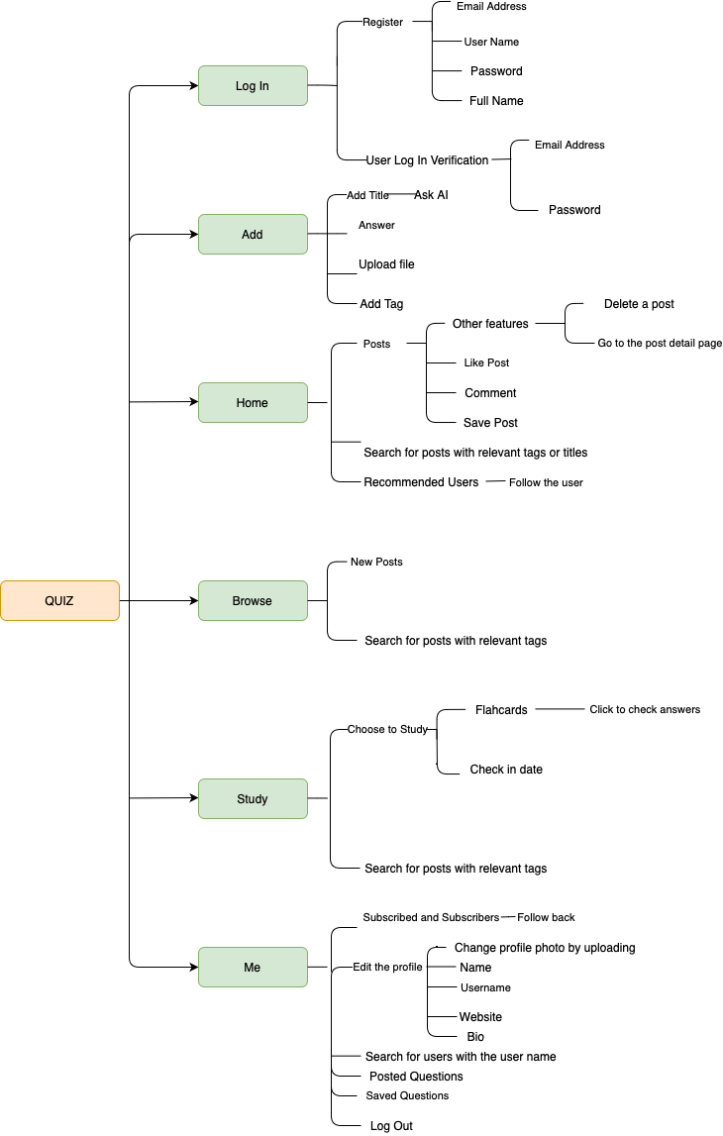

## **2.3 Features Illustration**

### 2.2.1 Add Question

As ChatGPT[1] and other machine learning models are more and more used in students’ studying process, we developed a platform that enables students to communicate, to study, and to get the answers not only by other users, but also by artificial intelligence. We believe, if most of the times ChatGPT can solve the problem, we can take the advantage to solve the problem by combining the traditional peer-to-peer interaction and AI.

By clicking the ‘Add Question’ button, we can edit the details of a new question and even upload your document to better illustrate your question, and by clicking ‘Share’, this question will be posted on the website, waiting for others to answer:

Alternatively, you can also choose to ask AI, the following picture shows when a question is added to the title, simply by clicking ‘Ask AI’, the answer generated from ChatGPT will be shown in the ‘Add answer’ part.

The pictures will upload to the Cloudinary as follows.

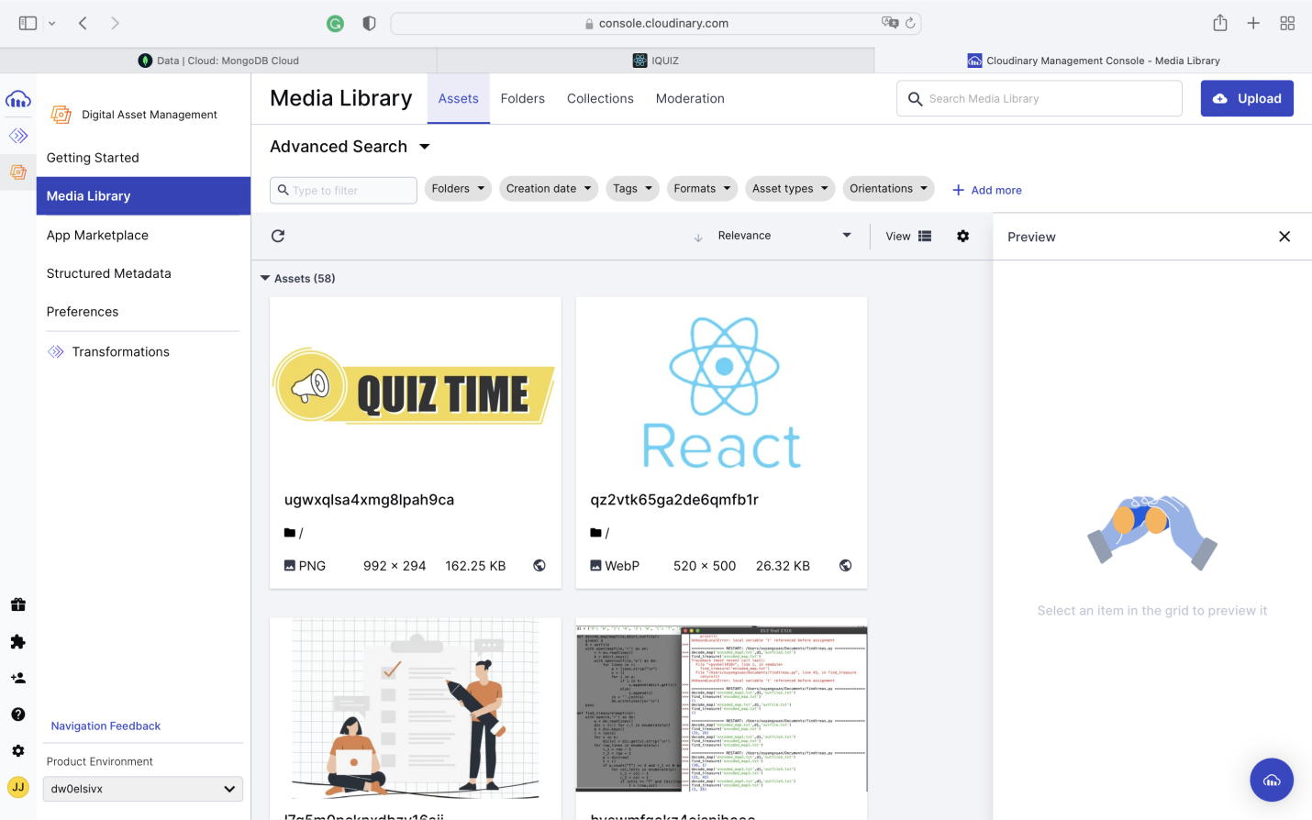

Succeed.

### 2.2.2 Home

As can be seen in the picture below, either clicking on the ‘home’ or on the logo on the top-left of the page, will lead us to the home page, where the newly posted questions and the recommended users are displayed. In this page, you can choose to like, to comment, and/or to save the questions, and you can choose to subscribe the recommended users.

When there’s no user added, the website appears like this:

And for users, the home page shows below will have the functions as mentioned above.

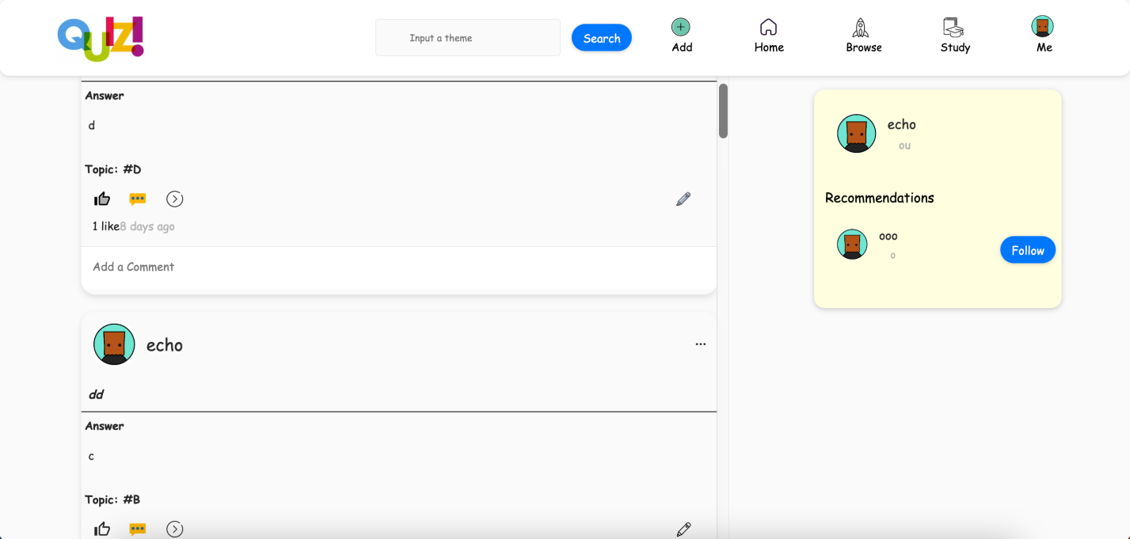

When clicking on the comment button on the bottom-left of every question to leave a comment:

And we can search the question by entering the title and the tag of the question, for example, we can input ‘D’ for search:

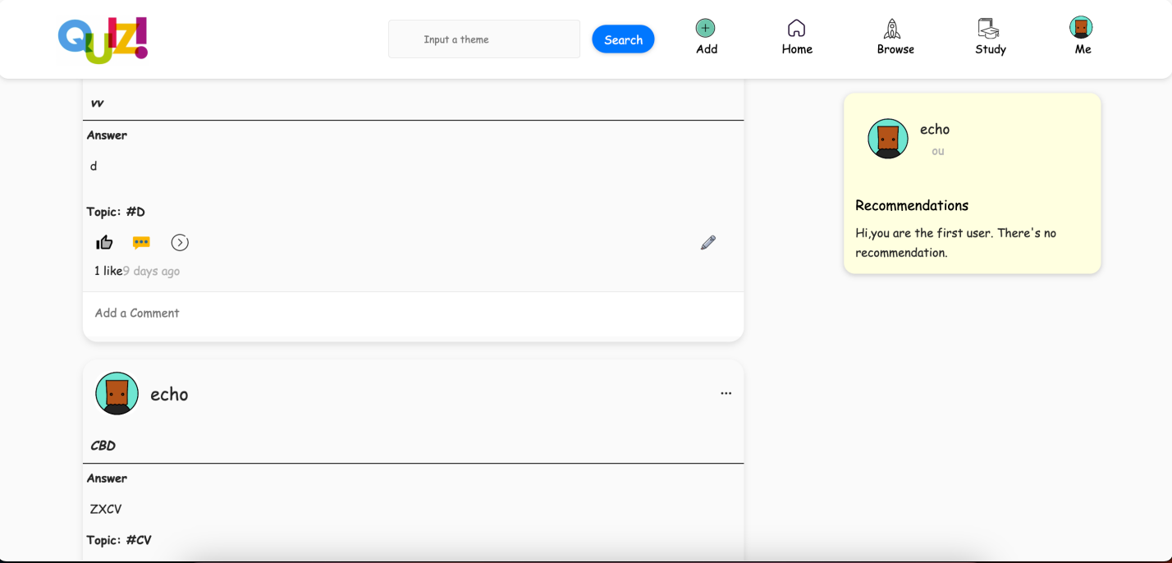

And by clicking on the ‘...’ on the top-right of every individual question, you can choose to delete the question or go to the details of the question.

And the ‘Check Details’ will lead us to the details of the question, which looks like this:

### 2.2.3 Browse

The browse page will show all the new questions for exploration, simply by clicking on the ‘Browse’ button. And we can search the question by entering the tag of the question. And our key feature is our recommendation algorithm. If the posted questions are more than eight, we will adopt the cosine_similarity imported from the sklearn library, and TfidfVectorizer to compute the similarity of the title and tags between the user’s liked questions and other questions that might be recommended to the user, and we get the four most similar question as the recommended question for the user displayed on the Browse page. (Only num>=8 questions can this recommendation shows)

When the questions exceed eight, we start to give our recommendations:

And when we search by the tags:

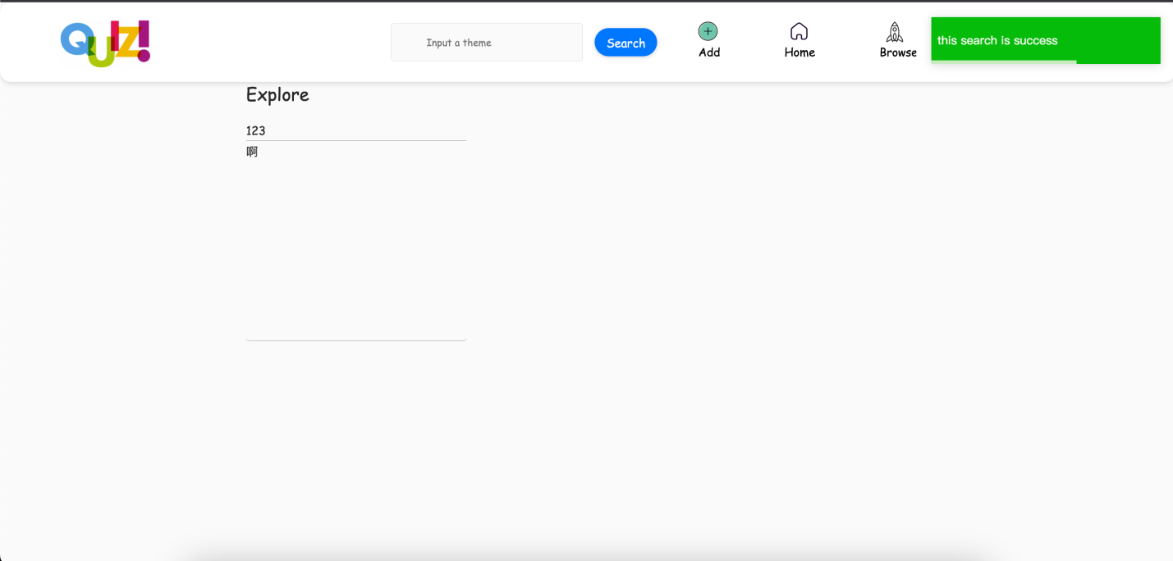

### 2.2.3 Study

In the study page we can select a tag to browse the questions as well as choose to study by using flashcards. Firstly, we can use the tags to filter the question:

And when choose ‘Let’s QUIZ!’, users can study with flashcards:

Users can choose to check the answer by clicking on the flashcard. So, we can help them to see if they have memorized the answer for the question.

### 2.2.4 Profile

The user’s profile page contains the details of the user’s profile, the user’s subscription, the user’s subscribers, the questions of the user (Q&A), and the user’s saved questions (Marker). We used the service provided by Cloudinary[2], to enable updates of the profile photos to be uploaded to and saved at the cloud server.

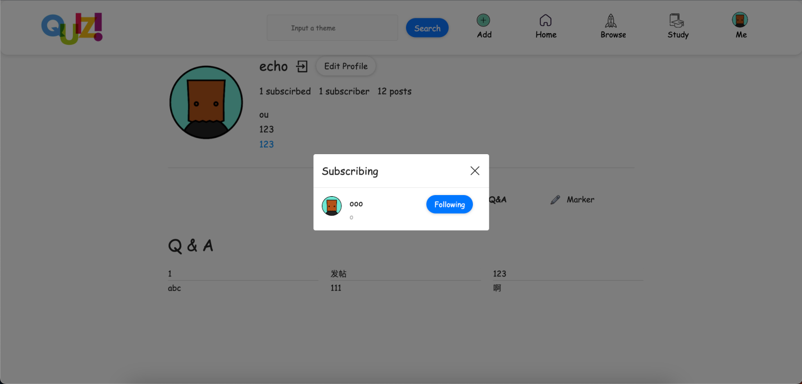

And we can search for other users by inputting their username, for example, we search for the user ‘ooo’:

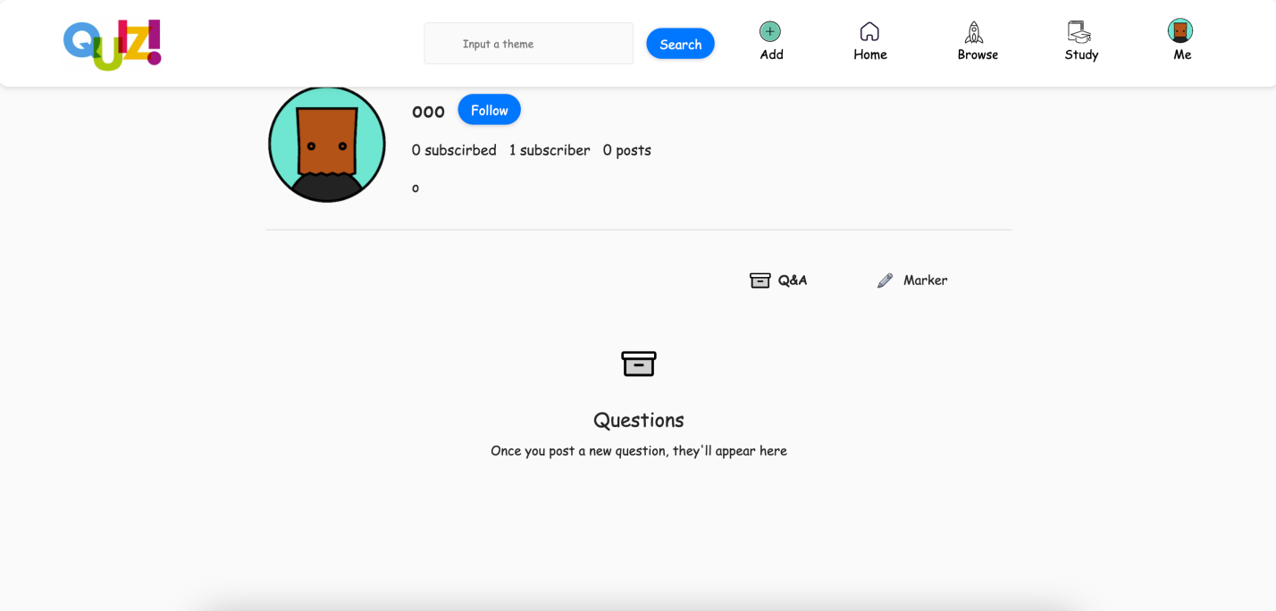

Users can log off their account by clicking on the door button, and users can also edit their profile details and even their profile photos.

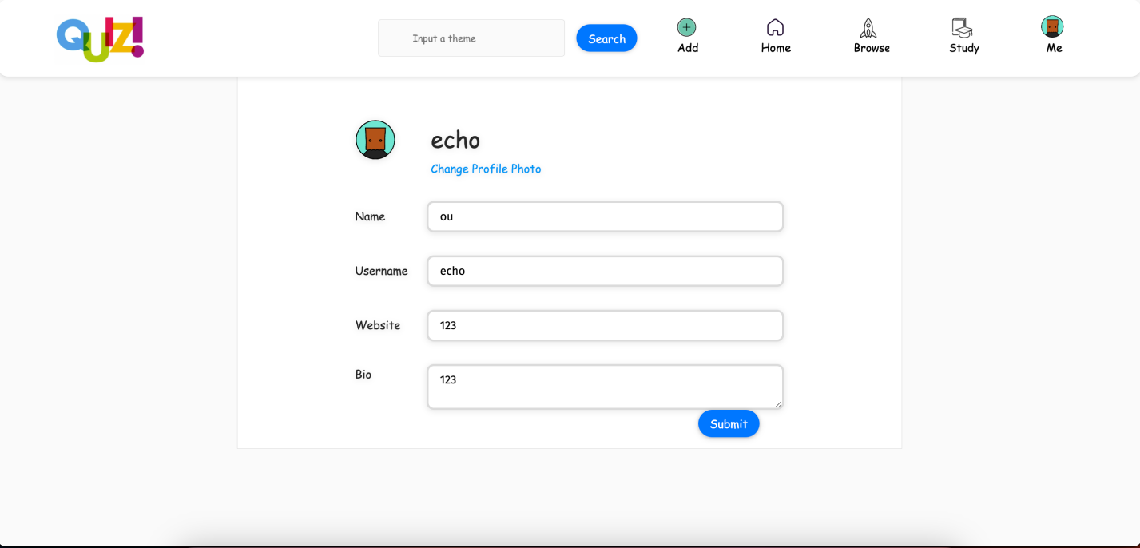

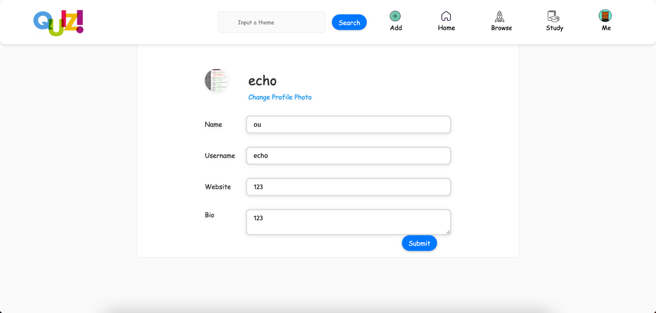

### 2.2.5 User’s Log In

The user can register on this page, and upon registration, they can log into their account with the registered email address during registration. And the JSON Web Token(JWT) is used for the user verification process, as it is a compact and self-contained way to securely transmit information, and encrypts to provide confidentiality between parties, and is commonly used for authorization.

### 2.2.5 Copyright

Here are 3 methods to prevent copying. Firstly, encrypting your code makes it unreadable unless it is decrypted with a key, which can prevent others from copying or reverse engineering your code. Secondly, implementing a licensing system that limits the usage of your code to only those who have purchased it can help prevent unauthorized copying. Lastly, registering my code as a trade secret or copyright it gives me legal recourse if someone does copy it.

And we used the MIT license for our code.

## **References and Resources**

1. OpenAI

[https://chat.openai.com](https://collegescorecard.ed.gov/data/)

1. Cloudinary

[https://cloudinary.com](https://collegescorecard.ed.gov/data/)

1. JWT

<https://jwt.io>

## **Group Assignment**

Jianwen Wei:

Developed project framework, responsible for Home, Browse, addQuestions, Navigation bar, Quiz login and register web front-and back-end.

Integrated Chatgpt api, recommendation system api.

Built DB, JWT, and Cloudinary.

Revised report.

Recording for video.

Zichen Yang:

Developed login and register pages.

Developed Study page.

Modify website style.

Overall code consolidation and modification.

Add Comment to the project.

Xuan OuYang:

Developed search functions.

Developed Profile page.

Add Icons to the projects.

Wrote report.

1. We used the api provided by OpenAI.
2. We used the api provided by Cloudinary.